SIEMENS CURRENT LIMITING RELAY

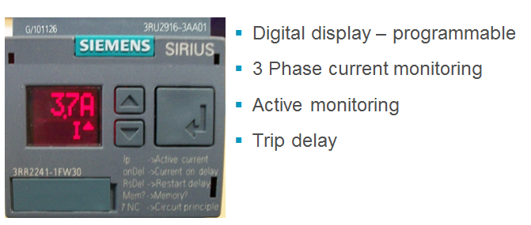

Symptoms: In certain operating and loading conditions, the origional over current relay may be oversensetive and trip the main circuit breaker.

Temporary repair:
To keep the unit from tripping you can disconnect the wire that goes to the shunt coil to the OCR device ( per Brian Lahr) Wire 31. The main circuit breaker remains in place for protection.
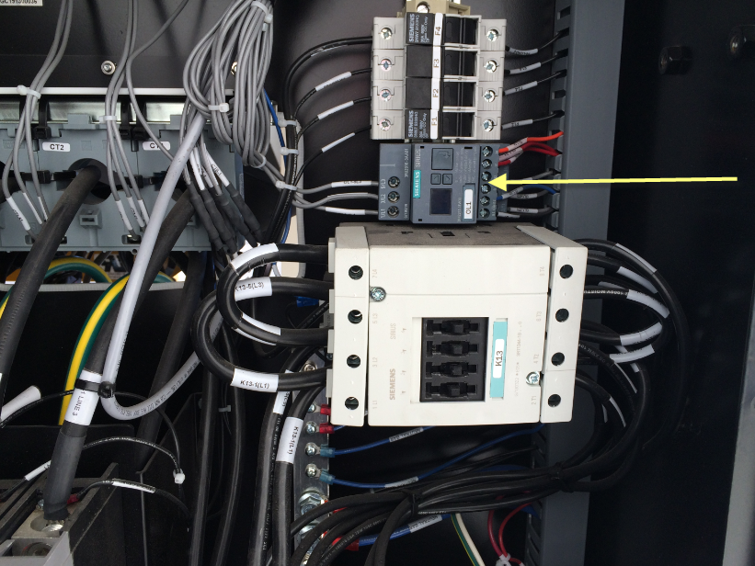

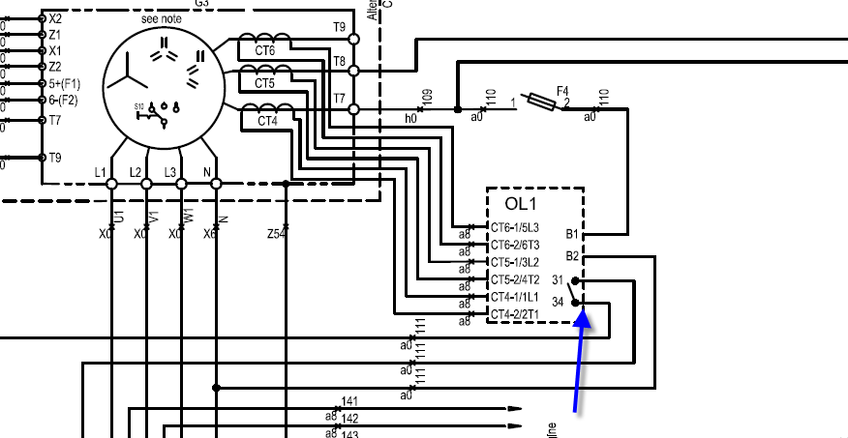

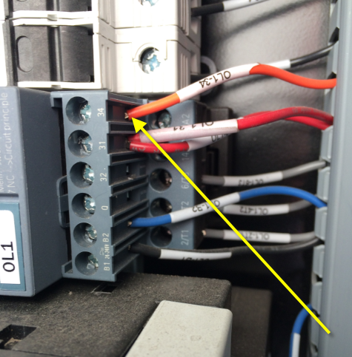

Disconnect wire OL134 from terminal 34 on the relay. Cover the bare end of the wire with electrical tape or a wire nut.
You are done with the temporary repair.

At your earliest conveience, order and install a new 1310 0742 22 over current relay and remove two of the current transformers. Follow the programming and instructions provided by Technical Services. There will be a future ECB for this repair.

